Indian Marketplace API Integration Plan
Nov 4, 2026 · @CFO Inc_RREMC

Purpose and scope
Only Amazon.in and Flipkart publish developer docs you can build against directly. Myntra, Ajio, JioMart, Meesho and Snapdeal (partly) need credentials or partner approval from the marketplace. This doc sets out what each marketplace offers for orders, status, payments, settlement and inventory, which GitHub code can speed up the build, and the order to build it in.
- In scope: order fetch and status updates, returns, inventory and price sync, payments and settlement data for reconciliation.
- Marketplaces: Amazon.in, Flipkart, Myntra, Ajio, JioMart, Meesho, Snapdeal.

How marketplace integrations work
Every integration follows the same five steps. What changes between marketplaces is who grants access and which data is exposed.
- Get API access. Register as a developer or partner, or receive credentials from the marketplace.
- Seller authorizes your app. Your app receives access tokens, usually short-lived and renewed with a refresh token.
- Pull data on a schedule. Orders, shipments, returns and reports. Some marketplaces also push notifications when an order changes.
- Push data back. Inventory, price, packing and dispatch status, labels, invoices.
- Reconcile. Match settlement and payment reports against your order records.

Marketplace API availability
Amazon and Flipkart cover all five data areas through documented APIs. The rest need marketplace approval, and none of them document a settlement API.
Marketplace | API access | Orders and status | Inventory | Payments and settlement
Amazon.in | Public Selling Partner API (SP-API). Public developer (Appstore) or private developer (self-authorization) | Orders API v2026-01-01 (v0 order operations must be migrated by 27 Mar 2027); ORDER_CHANGE notifications | Listings Items API, Feeds API, FBA Inventory API | Finances API; Settlement Reports via Reports API
Flipkart | Public docs, now on the Flipkart API Platform Hub; OAuth with refresh token; sandbox at sandbox-api.flipkart.net | Order Management API v3: shipments, labels, packing, dispatch, manifest, cancel, returns, notifications | Listing Management API (price and inventory), or FTP feed | Report Management API: Settled Transaction, Sales, P&L, Commission Invoice, GSTR. Paid; third-party/partner tokens only
Snapdeal | Public docs. Seller authorization token, auth token and client ID per call | Pending orders, invoice, labels, manifest/handover sheet, shipped, cancelled. 7-day query window | Not found on the page checked | Not found
Myntra | No public portal. Myntra issues vendor ID and secret key; runs via approved partners | Myntra pushes orders; partner sends ready-to-dispatch, fetches invoice and label | Batches of 10; 200 calls/minute | Not found
Meesho | Supplier Panel API; Meesho approval required; test environment exists | Orders, returns, dispatch and AWB updates | Stock sync | Not found
Ajio | Through Fynd Platform (AJIO VMS extension) plus Ajio seller registration | Managed in Fynd order dashboard | Stock synced to Fynd | Not described
JioMart | Username and password from JioMart category manager; used through integrators | Orders fetched; cancelled, delivered and return statuses sync | Per-warehouse inventory push | Not mentioned

How to get API access
Access comes in two parts. First, your company registers once as a developer or integration partner. Then each seller either authorizes your app (OAuth) or hands you credentials that the marketplace issued to them. Only Amazon and Flipkart publish a partner registration process. For the other five, I found no public developer program; their access runs through the seller's account manager or a marketplace email.
Marketplace | Your registration (software provider) | What the seller does | What your app stores
Amazon.in | Register as a public SP-API developer through the Solution Provider Portal: accept the Solution Provider Portal Agreement and Data Protection Policy, and complete the developer profile. Public apps must be listed in the Selling Partner Appstore | Clicks Authorize, either in the Appstore or on your website (Seller Central consent URL /apps/authorize/consent/<app ID>), and signs in with Amazon (Login with Amazon OAuth) | Your client ID and secret, plus a refresh token per seller. Sellers must reauthorize every 365 days
Flipkart | Register at partners.flipkart.com and answer Yes to API Partner. Flipkart verifies within 72 hours. Then Profile > Manage API Access > Create Application, with an https redirect URL | Signs in at api.flipkart.net/oauth-service/oauth/authorize and approves; your app exchanges the returned code for tokens | Your app ID and secret, plus tokens per seller. The seller's own self-access app (Manage Profile > Developer Access) is for the seller only: Flipkart says not to share it with third parties
Snapdeal | No public registration found. Ask Snapdeal how a partner gets a clientId | Authorizes at Snapdeal's page authorize.snapdeal.com/authserverui/login, which returns a user token (as Unicommerce documents it) | X-Seller-Authz-Token, X-Auth-Token and clientId on every order API call
Myntra | No public program found. Integrators work with Myntra directly (Myntra issues the order-push token) | Asks their Myntra account manager to enable APIs, then copies Merchant ID and Secret Key from partnerportal.myntra.com. Warehouse ID comes from Myntra if requested | Merchant ID, Secret Key, Warehouse ID
Meesho | Email meesholink-integration@meesho.com with the seller's legal business name, Supplier Panel email, contact person, intent to integrate with your app, and your identifier for each selling location | Must already be registered on the Meesho Supplier Panel | One refresh token per location. Meesho replies in 24–48 hours and sends a seller-activation event to your webhook
Ajio | No public program found. Alternative: Fynd's AJIO VMS extension | Confirms API access with their Ajio account manager, then in Ajio Seller Central: Account > Modify Account Details > Add New POB User. Approval takes a few days | POB ID (starts with "DV") and API password. Exchanged for an access token that expires after 30 minutes
JioMart | No public program found | Gets a username and password from their JioMart category manager | Username, password, and a map of JioMart location IDs to your warehouses
What this means for the web app:
- Start now: register your company with Amazon (Solution Provider Portal) and Flipkart (partners.flipkart.com). Both processes are public.
- Ask for partner status: write to Snapdeal, Myntra, Ajio and JioMart's seller or partner teams; their partner terms aren't published.
- Onboarding screen per marketplace: an Authorize button for Amazon and Flipkart, a credential form for Snapdeal, Myntra, Ajio and JioMart, and a request flow for Meesho.
- Token handling: encrypt stored credentials; refresh Ajio tokens on a schedule; remind Amazon sellers before their 365-day reauthorization is due.

Recent changes to watch
All data in this doc was rechecked on 4 Nov 2026. Three recent changes affect the build.
Date | Marketplace | Change | Action for the web app
May 2026 | Amazon | Amazon had planned SP-API fees for third-party developers: $1,400 a year from 31 Jan 2026, plus monthly GET-call fees from 30 Apr 2026. Reports dated 14 May 2026 quote Amazon saying it "will not move forward" with them "at this time". Amazon's announcement page, as fetched on 4 Nov 2026, still describes the fees as delayed, not cancelled | Confirm the current fee status in the Solution Provider Portal before pricing your app. Sellers using SP-API only for their own business were never in scope
28 Jan 2026 | Amazon | Orders API v2026-01-01 released: one call returns full order data, no Token API needed for PII, package tracking for FBM orders. Six v0 operations (getOrders, getOrder, getOrderItems and others) must be migrated by 27 Mar 2027 | Build on v2026-01-01 from day one; don't use the v0 order operations
Current | Flipkart | Docs now live on the Flipkart API Platform Hub, with a sandbox (sandbox-api.flipkart.net) and a Swagger spec. Access tokens are described as lasting about 60 days and refresh tokens 180 days | Use the Hub as the main reference and test in the sandbox first
No official public developer portal was found for Meesho, Myntra, Ajio, JioMart or Snapdeal partner registration as of 4 Nov 2026.

Reconciliation approach
Use settlement APIs for Amazon and Flipkart, and report uploads for the other five.
- Amazon.in: pull settlement reports and financial events by API, then match them to orders automatically.
- Flipkart: the settlement reports need partner-level access and are paid. Until that's approved, import the settlement file downloaded from the seller portal.
- Myntra, Meesho, Ajio, JioMart, Snapdeal: no settlement API found. Build an upload screen in the web app that reads each portal's payment or settlement file (Excel/CSV), with one column mapping per marketplace.
- Matching key: order ID, plus shipment or sub-order ID where the marketplace uses one. Flag short payments, missing settlements and unclaimed returns.
Open question: confirm with each marketplace's seller support whether a settlement API is offered to approved partners.

GitHub repositories to use
Usable code exists only for Amazon and Flipkart. For Snapdeal, Meesho, Myntra, Ajio and JioMart, GitHub search found only scrapers, affiliate-API clients, website clones and dashboards. None of them calls the seller APIs, so don't use them. Stars and last-update dates are as of 4 Nov 2026.
Repository | Marketplace | Language | Stars | Last update | License | Use it for
amzn/selling-partner-api-sdk | Amazon | C#, Java, JavaScript, PHP, Python | 103 | Nov 2026 | Apache-2.0 | Amazon's official SDK. First choice for orders, finances, reports, listings
amzn/selling-partner-api-samples | Amazon | Java (and others) | 217 | Nov 2026 | MIT-0 | Amazon's sample code for common seller use cases
amzn/selling-partner-api-models | Amazon | OpenAPI files | 923 | Oct 2026 | Apache-2.0 | OpenAPI definitions to generate a client in any language
saleweaver/python-amazon-sp-api | Amazon | Python | 690 | Nov 2026 | MIT | Most-starred community Python wrapper
bizon/selling-partner-api-sdk | Amazon | TypeScript | 50 | Nov 2026 | MIT | Typed Node.js client, if the web app backend is Node
jlevers/selling-partner-api | Amazon | PHP | 438 | Oct 2026 | BSD-3-Clause | PHP client, if the backend is PHP/Laravel
Flipkart/flipkart-seller-api-java-sdk | Flipkart | Java | 0 | Sep 2022 | None listed | Repo under Flipkart's GitHub account. Reference only: not updated since 2022, and no license means you can't reuse the code
timslabs/flipkart-seller-api-php | Flipkart | PHP | 0 | Jul 2026 | MIT | Community port of the Java SDK: client-credentials and third-party OAuth, sandbox and production, orders and listings. New and unproven; test before relying on it
frappe/ecommerce_integrations | Amazon; Unicommerce (which connects to Indian marketplaces) | Python (ERPNext app) | 212 | Nov 2026 | GPL-3.0 | Shows how a production app syncs Amazon and Unicommerce orders into accounting. GPL-3.0: copying its code into a closed-source web app is restricted
The web app's backend language isn't stated here. Pick the Amazon client that matches it.

Suggested architecture
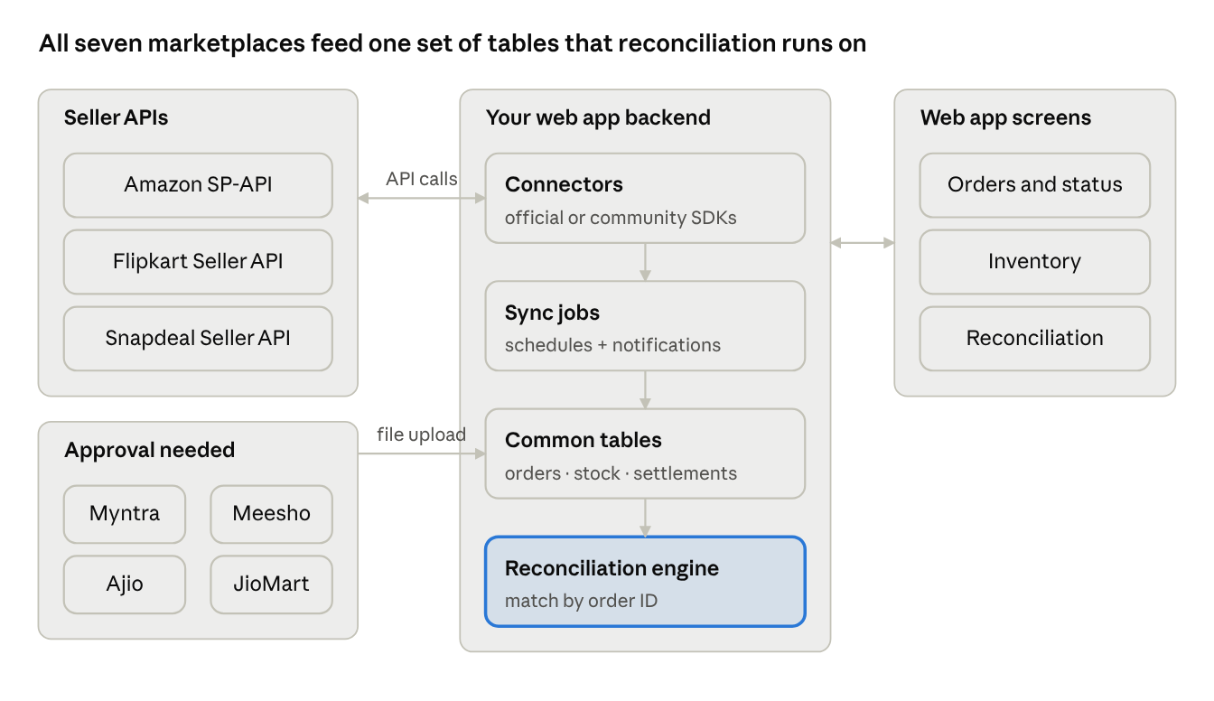
web app architecture · 7 marketplaces, 4 backend parts
Amazon, Flipkart and Snapdeal connect by API both ways: orders and statuses come in, inventory and dispatch updates go out. Myntra, Meesho, Ajio and JioMart need marketplace approval. Until they approve, their files are uploaded into the same tables.

Step-by-step implementation plan
Build Amazon first, then Flipkart, then the upload-based marketplaces. Each phase delivers working order sync before reconciliation.
- ☐ Amazon access: register as an SP-API developer in Seller Central (private app if only your own sellers will use it, public app for many sellers).
- ☐ Amazon connector: install the official SDK (or the community client for your language). Pull orders, listen for ORDER_CHANGE notifications, push inventory through Listings or Feeds.
- ☐ Amazon reconciliation: pull settlement reports through the Reports API and financial events through the Finances API; match them to orders.
- ☐ Flipkart access: create an app in the Flipkart seller API portal. Ask api-partner-support@flipkart.com about partner access to the Report Management API (settlement reports).
- ☐ Flipkart connector: Order Management API v3 for shipments, labels, dispatch, returns; Listing Management API for price and inventory.
- ☐ Flipkart reconciliation: Settled Transaction report by API once partner access is approved; portal file upload until then.
- ☐ Snapdeal: request seller API credentials (seller authorization token, auth token, client ID) and build order sync from its public docs.
- ☐ Myntra, Meesho, Ajio, JioMart: apply to each for API or partner access. Meanwhile, build file upload for orders and settlements, or connect through an integrator such as Unicommerce.
- ☐ Common layer: one order table and one settlement table for all marketplaces, with a mapping per marketplace.
- ☐ Security: keep client secrets and refresh tokens encrypted on the server, never in the browser.

Sources
- Amazon SP-API Seller Use Cases
- Amazon SP-API: Request a report
- Flipkart Seller API docs
- Flipkart Order Management API
- Flipkart Report Management API
- Snapdeal Seller APIs: Order Management
- Increff: Myntra V4 Integration
- Ecosire: Meesho connector docs
- Fynd: Ajio integration
- Unicommerce: JioMart integration
- GitHub repositories: linked in the table above (checked through the GitHub API on 4 Nov 2026)
- Amazon SP-API: Set up the authorization workflow
- Amazon SP-API: Registration overview
- Flipkart Marketplace Seller APIs: access and authentication
- Unicommerce: Snapdeal tokens
- Vin eRetail: Myntra integration
- Fynd: Register on Meesho
- EasyEcom: Meesho API integration
- Base: Ajio integration
- Eshopbox: Ajio access token flow
- Amazon SP-API changelog: Orders API v2026-01-01
- Amazon Solution Provider Portal announcement
- PPC Land: Amazon drops SP-API fees (14 May 2026)
- Flipkart API Platform Hub: Getting started
- Flipkart Seller API release notes

